+

EMREX Bridge Flow

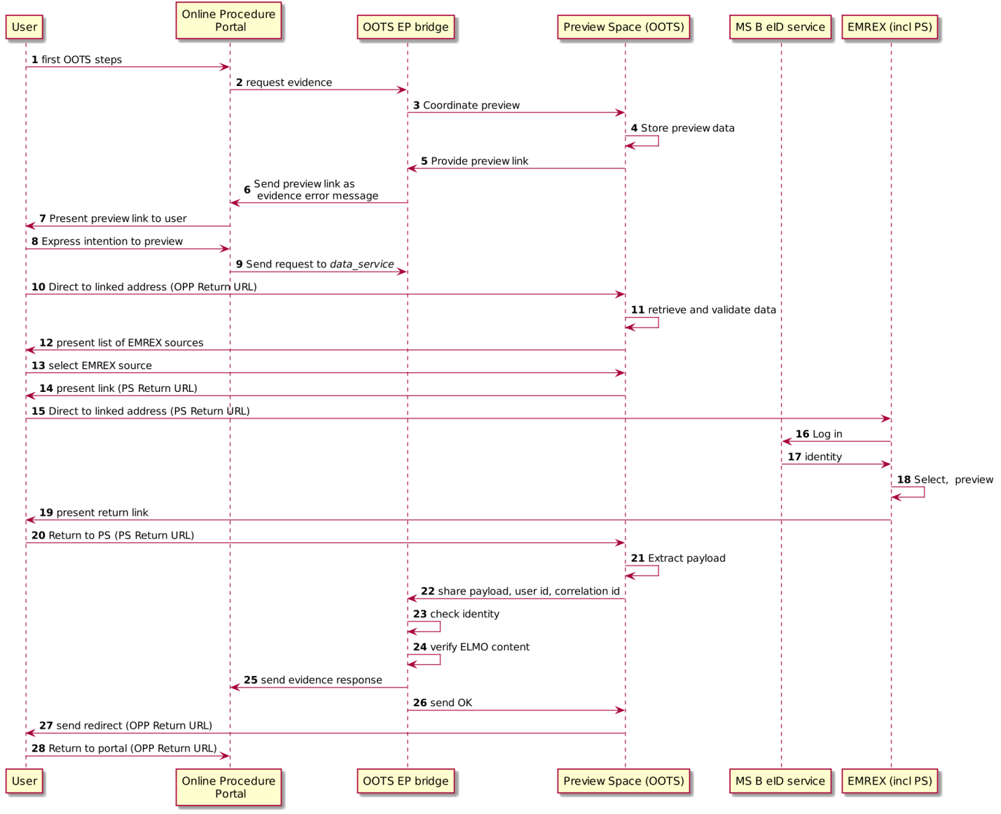

|  |  |  |
| --- | --- | --- |
| Step | Description | Notes |
| 1 | This diagram omits the description of the steps prior to requesting evidences, in particular the interaction with the Evidence Broker and Data Service Directory and selection of Data Service. | For Data Service provided indirectly by EMREX, the DSD will hold a registration of the bridge such that requests are delivered there. |
| 2 | Following the regular OOTS protocol, an evidence request is sent by the portal. |  |
| 3-5 | The OOTS portal sets up and creates a link to the user, inviting her to move to a location from which she can interact with EMREX providers.  The link will be personalized and session specific. It is linked to the requested evidence type and identity attributes of the user for validation. | Bridge and preview space could be a single component for simplicity. |
| 6 | The created link is sent to the portal to invite the user to navigate to the bridge. | This completes the first OOTS request-response loop. |
| 7-8 | If the user accepts the invitation, in parallel she is redirected using the provided link and the second loop starts. |  |
| 9 | The second request loop is sent to the bridge as an eDelivery request. It includes the unique preview link so that it can be correlated to user activity on the OOTS preview space.  It also includes a return URL allowing the user to return to the Procedure Portal. | The final response will be returned to the portal as a response to this request. |
| 10,11 | In parallel, the user follows the presented link. For the link, the OOTS preview space can prepare preview. | The link provides session information and the identity and requested evidence type data. |
| 12-13 | It can help the user make use of the EMREX directory feature to select a specific EMREX evidence provider. | A single OOTS preview space can serve multiple EMREX providers. For example, there could be one OOTS EMREX bridge per MS that service multiple universities.  Its purpose is not so much to actually preview, as that is done at the EMREX provider side, but the intercept the user’s navigation between the OOTS and EMREX worlds. |
| 14-15 | Based on user input, she can be redirected to the selected EMREX evidence provider. This link also contains return URL, but it is a different one that redirects the user to the OOTS preview space. | This link also needs to be unique and correlated with the session state. |
| 16-18 | The user completes the server side interaction with EMREX. | This is regular EMREX processing, it requires the user to re-authenticate, select, preview, approve etc. |
| 19-20 | Once the user has completed her activity at the provider, she follows the presented link. | In EMREX, the selected payload is packaged with the user as she moves to the specified return address. EMREX does not have a separate messaging channel. |
| 21 | The user revisits the OOTS preview space.  This visit has as main purpose to separate the user from the EMREX payload, as these two will return separate to the Procedure Portal | There is no actual second preview as this has been done at step 18. |
| 22 | Using stored correlation data, the original user identity data and session information is retrieved. We also get the Procedure Portal return URL so we can forward the user. | The Procedure Portal link was stored at step (10).  ELMO |
| 23 | From the EMREX response, we get the identity data for the user. This needs to match the original identity attributes. Also, there must have been a second request (step 9) to which it can create an evidence response. | The EMREX provider could not do this as it did not have the evidence request.  The original identity attributes were stored at steps at steps 4 and 9. |
| 24 | The ELMO payload is validated. | Verification of the XML signature and possibly XSD conformance. |
| 25 | If the checks are passed successfully, the EMREX data can be used to create an OOTS response that include the EMREX payload. | In OOTS, the payload is exchanged via eDelivery AS4, RegRep4 and OOTS profiling defined in OOTS TDDs. |
| 26 | The OOTS preview space receives a signal that the user can be redirected back to the procedure portal. | This uses the Procedure Portal return URL shared in the step 14. |
| 27-28 | The user returns to the procedure portal | This is just the user, not the payload. |